Bangladesh Medical Association (BMA)
List of Life Member-42
09. BMA Chapai Nawabganj Branch

Sl No | Voter No | Voter Details
1 | Voter No  LM-0900001  No Image | DR. NAZLI BEGUM  F/Name:  M/Name:  BM & DC Reg. No:  NID:  Cell:  Address: Senior Consultant (Gynae) Sadar Hospital Chapainawabgonj  Blood Group:
2 | Voter No  LM-0900002  No Image | DR. HOSNEARA BEGUM  F/Name:  M/Name:  BM & DC Reg. No:  NID:  Cell:  Address: Islampur, Chapainawabgonj  Blood Group:
3 | Voter No  LM-0900003  No Image | DR. SHIRAJEE NAZMUL HASNAIN  F/Name:  M/Name:  BM & DC Reg. No:  NID:  Cell:  Address:  Blood Group:  TRANSFERED to BMA Dhaka City  LM-1405543
4 | Voter No  LM-0900004  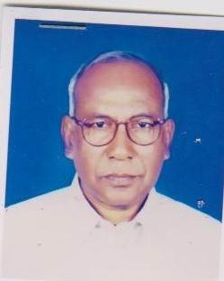 | DR. MD. ABUL HASAN  F/Name: Tamizuddin Ahmid  M/Name:  BM & DC Reg. No:  NID:  Cell:  Address: Seba Clinic Chapi-Nawabganj  Blood Group:
5 | Voter No  LM-0900005  No Image | DR. MUKTARA BEGUM  F/Name:  M/Name:  BM & DC Reg. No:  NID:  Cell:  Address:  Blood Group:  TRANSFERED to BMA Dhaka City  LM-1405543
6 | Voter No  LM-0900006 | DR. MD. MOYAJ UDDIN  F/Name: Md. Marshad Ali  M/Name:  BM & DC Reg. No:  NID:  Cell:  Address: College Road, Chapi-Nawabganj  Blood Group:
7 | Voter No  LM-0900007  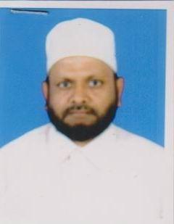 | DR. MD. EMDADUL HAQUE  F/Name: Md. Mozahar Ali  M/Name:  BM & DC Reg. No:  NID:  Cell:  Address: Seba Clinic Chapi-Nawabganj  Blood Group:
8 | Voter No  LM-0900008  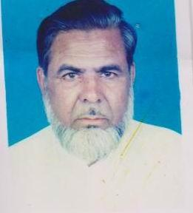 | DR. MD. YASIN ALI  F/Name: Late Alhaj Md.safa Tullah  M/Name:  BM & DC Reg. No:  NID:  Cell:  Address: Rohnpur, Chapi-Nawabganj  Blood Group:
9 | Voter No  LM-0900009  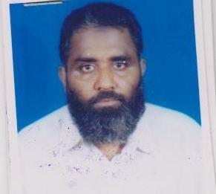 | DR. ANWAR ZAHID  F/Name: Md. Abul Hayat Mia  M/Name:  BM & DC Reg. No:  NID:  Cell:  Address: Shantibug Chapi-Nawabganj  Blood Group:
10 | Voter No  LM-0900010  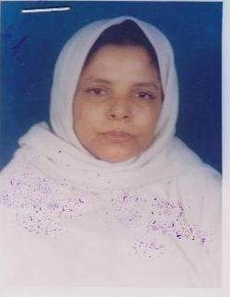 | DR. S. F. JESMINE  F/Name: A. K. Zohrulhaque  M/Name:  BM & DC Reg. No:  NID:  Cell:  Address: Shantibug Chapi-Nawabganj  Blood Group:
11 | Voter No  LM-0900011  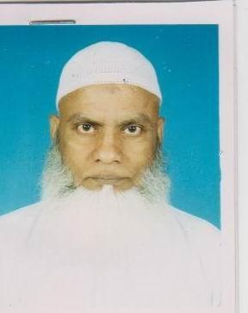 | DR. ASHRAFUL ISLAM  F/Name: Md. Akram Ali  M/Name:  BM & DC Reg. No:  NID:  Cell:  Address: Rohanpur Bazar Chapi-Nawabganj  Blood Group:
12 | Voter No  LM-0900012  No Image | DR. NOOR MOHAMMAD NOORU  F/Name:  M/Name:  BM & DC Reg. No:  NID:  Cell:  Address:  Blood Group:  TRANSFERED to BMA Dhaka City  LM-1405543
13 | Voter No  LM-0900013 | DR. MD. NADEEM SARKAR  F/Name: Md. Olam Mortuza  M/Name:  BM & DC Reg. No:  NID:  Cell:  Address: Assistant Surgeon, Islampur Union Health Sub-Centre, Chapai Nawabganj.  Blood Group:
14 | Voter No  LM-0900014  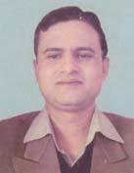 | DR. MONJUR A KHODA  F/Name: Md. Altaf Hossain Mondal  M/Name: Mrs. Rezia Khanom  BM & DC Reg. No: 37717  NID: 1018156950120  Cell: 01712111190  Address: Dormitory, Upazilla Health Complex Nachole, Chapai Nawabgonj  Blood Group: A+
15 | Voter No  LM-0900015 | DR. MD. ABDUS SOBHAN  F/Name: Late Samser Ali  M/Name: Late Budon Bibi  BM & DC Reg. No: 19369  NID: 8192213208250  Cell: 01711351984  Address: Adhunik Sador Hospital, Chapainawabganj  Blood Group: B+
16 | Voter No  LM-0900016  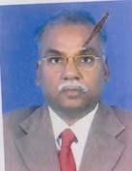 | DR. ANWARUL ISLAM CHOWDHURY  F/Name: Late Nur Mohammad Chowdhury  M/Name: Late Esma Khatun  BM & DC Reg. No: 10401  NID: 7026609160192  Cell: 01720084834  Address: Programme Manager (Non Clinical Management Training) DGHS, Mohakhali, Dhaka  Blood Group: A+
17 | Voter No  LM-0900017 | DR. MD. ABDUL MATIN  F/Name: Nazrul Islam  M/Name: Sufia - Khatun  BM & DC Reg. No: 18243  NID: 7026615198538  Cell: 01712274893  Address: Medical Officer, Civil Surgeon Office, Chapai Nawabganj  Blood Group: B+
18 | Voter No  LM-0900018 | DR. MD. OMAR FAROOQUE SARWAR HOSSAIN  F/Name: Late Latif Hossain  M/Name: Late Begum Fatema Khatoon  BM & DC Reg. No: 9857  NID: 7026615199167  Cell: 01731709649  Address: Jun. Con. Cardiology, Sadar Hospital Chapai Nawabganj  Blood Group: O+
19 | Voter No  LM-0900019  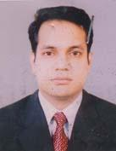 | DR. ABU SHAHIN MOHAMMED MAHBUBUR RAHMAN  F/Name:  M/Name:  BM & DC Reg. No: 34910  NID: 7026614195499  Cell: 01763248448  Address: House #441, Arambagh, Chapainawabganj  Blood Group: O+  TRANSFERED to BMA Dhaka City  LM-1405543
20 | Voter No  LM-0900020 | DR. MOHAMMAD ABUL KASEM  F/Name: Late Islam Uddin  M/Name: Mst. Jamila Khatun  BM & DC Reg. No: 17825  NID: 19638198503000001  Cell: 01716783763  Address: Peadiatric Consultant (Incharge) Sadar Hospital Chapai Nawabganj  Blood Group: O+
21 | Voter No  LM-0900021 | DR. JAMIL RAIHAN  F/Name: Md. Mozammel Haque  M/Name: Most. Rehana Begum  BM & DC Reg. No: 24607  NID: 8198506402367  Cell: 01711068301  Address: Jr. Consultant (Anaesthesia), Sadar Hospital, Chapai Nawabgonj  Blood Group: B+
22 | Voter No  LM-0900022 | DR. MD. ABDUS SALAM  F/Name: Late Saifuddin Miah  M/Name: Julekha Begum  BM & DC Reg. No: 16886  NID: 7026615198534  Cell: 01711068408  Address: 59, Mistri Para, P.O. & Dist.- Chapai Nawabgonj  Blood Group: A+
23 | Voter No  LM-0900023  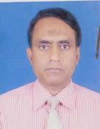 | DR. MD. GOLAM RABBANI  F/Name: Md. Abul Hossain  M/Name: Mst. Sefaly Khatun  BM & DC Reg. No: 19130  NID: 7026603123549  Cell: 01712013738  Address: Pinki Manjil, JailKhana Road, Shahibag,, Chapai Nawabganj  Blood Group: O+
24 | Voter No  LM-0900024  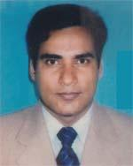 | DR. BE-NAZIR AHMMAD  F/Name: Md. Mazharul Hannan  M/Name: Mrs. Munjerina Hannan  BM & DC Reg. No: 26788  NID: 2696402522132  Cell: 01720038608  Address: Junior Consultant (Child), Adhunik Sadar Hospital, Chapai Nawabgonj  Blood Group: B+
25 | Voter No  LM-0900025  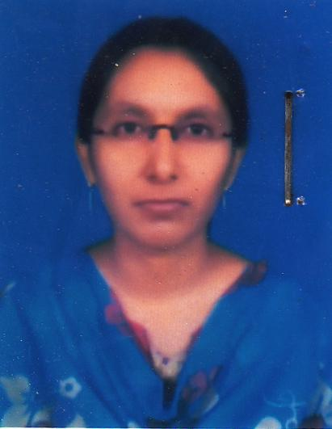 | DR. FATIMA TORSA JYOTI  F/Name: Abu Ahmed Enamul Kabir  M/Name: Most. Munira Sultana  BM & DC Reg. No: 71026  NID: 7026603118930  Cell: 01710242701  Address: Vill: Mistripara, Post & Dist: Chapai Nawabganj  Blood Group: A+
26 | Voter No  LM-0900026 | DR. MD. NOOR ASHAD-UZ-ZAMAN  F/Name: Md. Abdul Khaeque  M/Name: Noor Aktar Jahan  BM & DC Reg. No: 52612  NID: 7026601107447  Cell: 01717094205  Address: Medical Officer, NIPSOM, Mohakhali, Dhaka  Blood Group: O+
27 | Voter No  LM-0900027 | DR. MD. TAJ UDDIN  F/Name: Late. Md. Abdul Majid  M/Name: Late. Shahar Banu  BM & DC Reg. No: 11683  NID: 19547026615198537  Cell: 01712051979  Address: MEDI CARE CLINIC, CHAPAI NAWABGANJ  Blood Group: O+
28 | Voter No  LM-0900028 | DR. MD. DURRUL HUDA  F/Name: Md. Lokman Ali  M/Name: Mst Jahanara Begum  BM & DC Reg. No: 19722  NID: 7026611167201  Cell: 01711066510  Address: Chapai Nawabgonj  Blood Group: AB+
29 | Voter No  LM-0900029  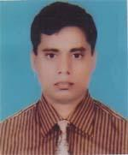 | DR. MD. ISMAIL HOSSAIN  F/Name: Md. Tabarok Ali  M/Name: Mst. Ayesha Begum  BM & DC Reg. No: 39162  NID: 7026601102280  Cell: 01712583843  Address: Vill+PO: Nayagola, PS+Dist: Chapai Nawabganj  Blood Group: B+
30 | Voter No  LM-0900030  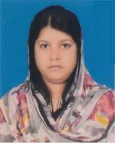 | DR. SULTANA PAPIA  F/Name: Late. Muhammad Ali  M/Name: Sayeda Farida Begum  BM & DC Reg. No: 48118  NID: 6125214208319  Cell: 01712060764  Address: MOCS (Coord), Cb office chapai nawabganj  Blood Group: A-
31 | Voter No  LM-0900031  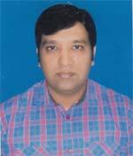 | DR. MD. NOOR BAKISH PARVEZ  F/Name: Abdullah Al Bakey  M/Name: Mrs. Tahomina Begum  BM & DC Reg. No: 45928  NID: 6125214208300  Cell: 01712060764  Address: RMO Jomjom Clinic, Shibgonj, Chapai Nawabganj  Blood Group: B+
32 | Voter No  LM-0900032 | DR. MD. REZAUL KARIM  F/Name: Md. Belal Uddin  M/Name: Most. Rabeya Basera  BM & DC Reg. No: 46789  NID: 8524904042865  Cell: 01712191850  Address: Department of Paediatrics, RMCH  Blood Group: A+
33 | Voter No  LM-0900033  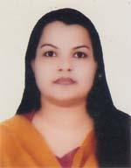 | DR. SAYRA KHAN  F/Name: Abdul Quddus Khan  M/Name: Mrs. Monowara Begum  BM & DC Reg. No: 50450  NID: 2693014965503  Cell: 01712947335  Address: Upazilla Health Complex, Sadar, Chapai Nawabganj  Blood Group:
34 | Voter No  LM-0900034  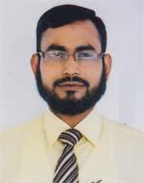 | DR. MD,. ZAHANGIR ALAM  F/Name: Md. Abu Mondol  M/Name: Most. Khadiza Begum  BM & DC Reg. No: 46715  NID: 19828198510366889  Cell: 01712269933  Address: Lakherajpara (Station Road), Chapai Nawabganj Sadar, Chapai Nawabganj  Blood Group: B+
35 | Voter No  LM-0900035 | DR. MD. AKTER HOSSAIN  F/Name: Late Abdus Sattar  M/Name: Mst. Rozelara Begum  BM & DC Reg. No: 19721  NID: 7028805217773  Cell: 01712039547  Address: CHEST DISEASE CLINIC, CHAPAI NAWABGANJ  Blood Group: O+
36 | Voter No  LM-0900036 | DR. ABDULLAH AL MAHFUZ  F/Name: Dr. Abdullah Al Mamun  M/Name: Nasera Begum  BM & DC Reg. No: 44672  NID: 7026611171098  Cell: 01723811899  Address: NATUN HAT, NAMOSHANKAR BATY, SADAR THANA, CHAPAI NAWABGANJ  Blood Group: B+
37 | Voter No  LM-0900037  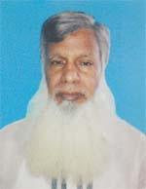 | DR. MD. ASHRAFUL HAQUE  F/Name: Late. Mofizuddin Biswas  M/Name: Late. Bclemur Khatun  BM & DC Reg. No: 50448  NID: 7011856669269  Cell: 01712600154  Address: Saifursha Mokbul Charitable Hospital, Chapai nawabganj  Blood Group: O+
38 | Voter No  LM-0900038 | DR. JAVIN FERDOUSHI ISLAM  F/Name: Md. Nazrul Islam  M/Name: Mst. Sulatana Laizu  BM & DC Reg. No: 41053  NID: 19777011818650083  Cell: 01711583374  Address: VILLAGE- CHAR DHARAMPUR, P.O: BHOLAHAT, DIST- CHAPAINAWABGANJ  Blood Group: O+
39 | Voter No  LM-0900039  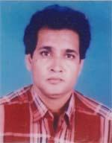 | DR. TARIT KUMAR SAHA  F/Name: Late. Dr. Bijoy Kumar Saha  M/Name: Donuj Doloni Saha  BM & DC Reg. No: 17346  NID: 7018841700939  Cell: 01711014202  Address: House#11/B, Road#130, Gulshan-1, Dhaka-1212  Blood Group: B-
40 | Voter No  LM-0900040 | DR. MD. NOOR A ALAM SIDDRQUE  F/Name: Late. Md. Anwar Ul Alam  M/Name: Mst. Kamrun Nahar Alam  BM & DC Reg. No: 96275  NID: 5511269036  Cell: 01742295206  Address: Vill: Chunakhali Post: Ramchancropur Hut- 6302, Upzila: Chapai Nawabgnj Sadar, Chapai Newabganj.  Blood Group: O-
41 | Voter No  LM-0900041 | DR. MUHAMMAD ALI CHOWDHURY  F/Name: Md. Sirajul Mannan Chowdhury  M/Name: Reshma Chowdhury  BM & DC Reg. No: 94207  NID: 9118600148  Cell: 01747251767  Address: Holding Number: 1142, Village: Bajitpur Chowdhurypara P.O: Kansat, Upazila: Shibganj, Dist: Chapai Nawabganj.  Blood Group: A+
42 | Voter No  LM-0900042 | DR. MUSHFIQUR RAHMAN  F/Name: Abdul Karim  M/Name: Tajkera Begom  BM & DC Reg. No: 83501  NID: 1468008618  Cell: 01723580240  Address: Vill: Ramkristopur post- Bottola hat Thana- Chapai Nawabganj Zilla- Chapai Nawabganj.  Blood Group: B+

